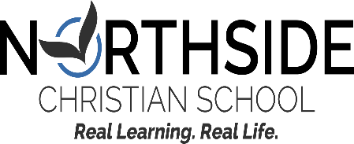

2022-2023 Dress Code (K-8)

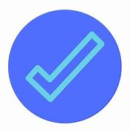
MONDAY/WEDNESDAY/FRIDAY

Wear This: Plain or patterned tops, pants, shorts, skirts & dresses
` (shorts, skirts & dresses must be no shorter than 3” above your knee)
Tops: Hoodies, sweaters, sweatshirts, collared, non-collared, t-shirts, polos, long or short sleeved
Pants: denim, khakis, or other durable pants
Shoes: comfortable
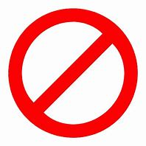
Not This: Tops and bottoms should be modest: no midriff skin showing when stretching or bending, and no low-cut shirts that are revealing when bending forward. No spaghetti straps, tank-tops, or crop tops.
Pajama bottoms or tops
Leggings, unless bottom is fully covered by a dress or long top
Rips or holes on any clothing item
Sweat or track pants (allowed on gym days only)
Hats or hoodies on your head when inside the buildings
Flip flops

GYM DAYS: TUESDAY/THURSDAY
Wear This: Track-style pants or shorts
Northside tees and sweatshirts
Athletic shoes
Not This: Leggings, jeggings, tight pants or shorts
Tops and bottoms should be modest: no midriff skin showing when stretching or bending, and no low-cut shirts that are revealing when bending forward. No spaghetti straps, tank-tops, or crop tops.
Hats or hoodies on your head when inside the buildings

MESSAGES FOR ALL CLOTHING
Wear This: Positive, faith-based or patriotic
Sports teams
Not This: Inappropriate words or images such as cursing, insults, or anything sexual in nature
Anti-American or anti-Christian
Drug/alcohol references

